Fall 2026: SI-MI Facilitator Guide

Introduction
Thank you for your interest in being a facilitator for the SI-MI Mentor Training Program! This quick guide will help you orient yourself to your role, expectations, and tasks.

Course Overview
SI-MI is a 7-session mentor training program that runs for a period of 13 weeks. Live sessions are 90 minutes long and held every two weeks on Zoom. After each session, an email is sent to participants with the session recording and the following session’s pre-work.

Course topics are as follows:
- Session 1: Orientation
- Session 2: Identity and its Intersections
- Session 3: Engaging in Empathic Conversations
- Session 4: Racialized Experiences in STEM
- Session 5: Color-Evasive Practices
- Session 6: From Deficit to Asset-Based Mentoring
- Session 7: Wrap-Up

Facilitator Duties
SI-MI is designed to employ at least two facilitators for each live session. Facilitator 1 is the main guide for the conversation, while Facilitator 2 provides backend support for the live session. Facilitator 2 may also add to the conversation throughout the session, but they are not responsible for leading it.

All facilitators are required to login to Zoom at least 15 minutes prior to the start of the session.

Here is a quick breakdown of each facilitator’s duties:

Facilitator 1 (Host)
- Welcomes participants as they come in
- Officially begins the live session when enough participants have joined
- Introduces each section of the session and begins the conversation
- Facilitates the discussion by validating participant responses, guiding them through questions, and ensuring the class stays on topic
- Introduces concepts and explains activities
- Adds to facilitator session notes after each session
- Sends reminder email to participants a few hours before the live session

Facilitator 2 (Co-Host)
- Lets participants into the Zoom
- Takes attendance
- Ensures the session is being recorded
- Copy / pastes all instructions and guiding questions into the Zoom chat
- Monitors the chat for comments or questions
- Creates breakout rooms with correct number of participants and time limit
- Shares their screen when slides are being presented
- Takes notes when necessary
- Adds to facilitator session notes after each session

Facilitator 3 (optional support host)
- Facilitator 3’s primary role is to support Facilitator 2 on the technical side. They would be responsible for starting and stopping the recording, taking attendance, and monitoring the chat.

Facilitator Training Workbook
- Dra. Nicole Cabrera Salazar from Movement Consulting has provided a Facilitator Training Workbook with information about what to keep in mind when facilitating, including group power dynamics, keeping conversations on track, validating participants’ responses, as well as technical information about how to set up Zoom.
- There is also a separate Zoom for SIMI tutorial document available as a resource.

Enabling Zoom Waiting Room (Optional)
- Please note that the Zoom room is set up in such a way that facilitators and participants are able to join at any time. If you and your fellow facilitators would like to enable the waiting room so that you can prepare for your session without an audience, you should:
  - Join the Zoom as early as you would like
  - Navigate to Host Tools at the bottom of your toolbar
  - Select “enable waiting room”
  - Let participants in when you’re ready to begin the session

Curriculum Folders
Main Curriculum Folder:
[LINK TO MATERIALS]
- This Google Drive houses the Participant and Facilitator folders

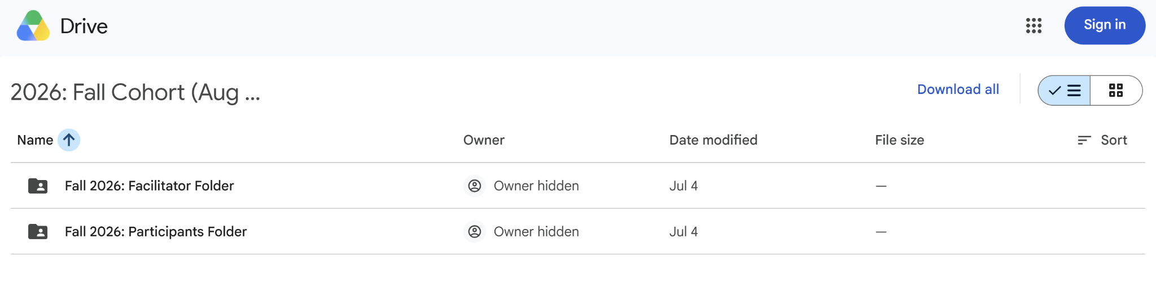

Facilitator Folder
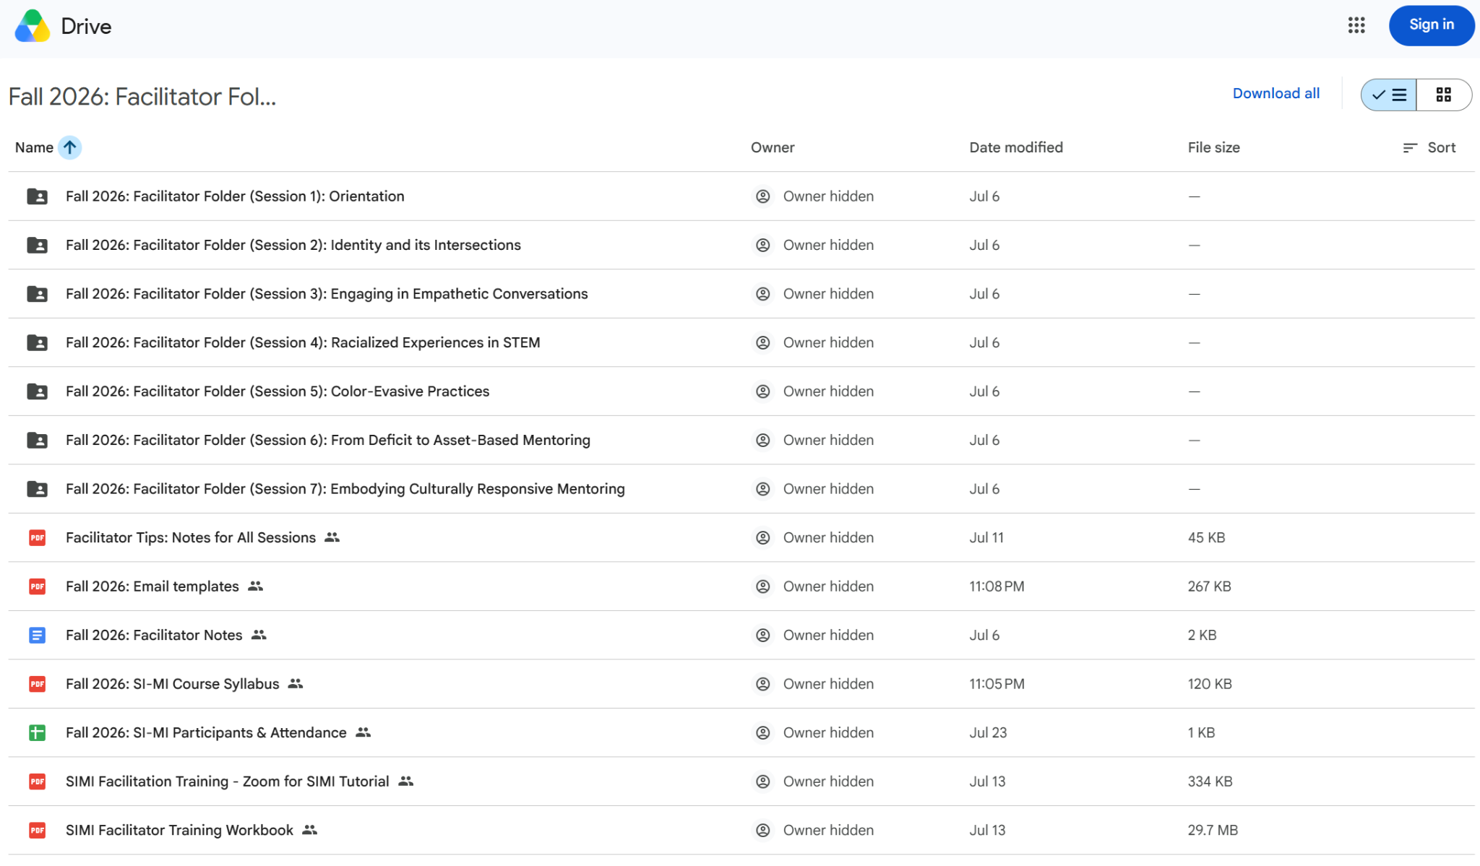

- Inside the Facilitator Folder are session folders organized by week which include all of the materials you will need for the training, including in-depth facilitation instructions.
- The Email Templates document has templates of what messaging should be sent out to participants before and after each session. Pre-session emails should be sent out one week before the live session date.
- The SI-MI course is designed to be iterative. At the end of each live session, we encourage facilitators to stay in the virtual room and discuss with each other what worked, what didn’t work, and prepare for the next module. We included a Facilitator Notes document to capture your thoughts. Each weekly facilitation guide has a link to this document, along with some guiding questions.
- The Facilitator Tips: Notes for All Sessions document has tips that previous SI-MI Facilitators found helpful when running their sessions. We saved this document as a resource for future Facilitators.
- Facilitator Guides: We provided two template types (content is the same in each): a Word document and an Excel document. The weekly facilitation guides have a detailed agenda with start/stop times, relevant links, scripts, and tips for what to watch out for.

Participants Folder
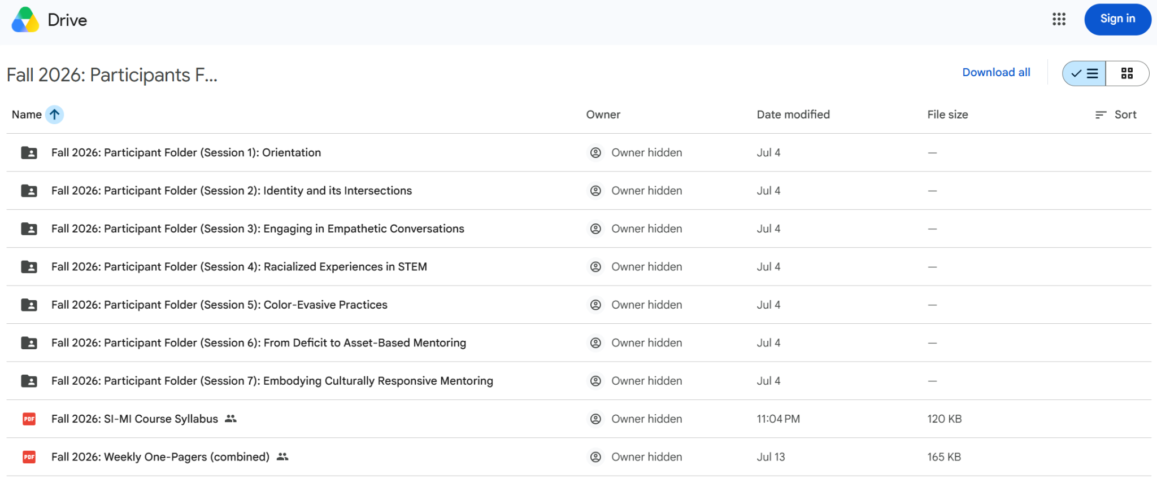

- The Participants Folder has folders for each weekly session. There is also a high-level SI-MI Course Syllabus and a Weekly One-Pager (combined) document for participants to reference throughout the course.
- Within each weekly session folder there is pre-work for that session, a pre-work and session agenda document, and a weekly one-pager document.

Surveys
- After each session participants are asked to complete a survey. This survey is optional and is meant to give facilitators feedback throughout the course so they can make any necessary adjustments. Survey feedback is collected into one main form, which should be reviewed by facilitators before each session.
- Pre- and Post-Assessments are required for the Fall 2026 cohort, but will be optional going forward. If you’d like to set up additional surveys and/or pre-post assessments in the future, please reach out to the SI-MI Organizing Team for potential collaboration.

Optional: Padlet
- Previous cohorts have found it useful to set up a Padlet for the course. Padlet is a free online collaboration platform. Past participants have found this a useful place to chat with other participants between live sessions, sharing questions and insights about pre-work and reflections from previous sessions.
- If you choose to set up a Padlet for your cohort, the Facilitator should plan to briefly reference comments and discussions from the platform during the synchronous session.
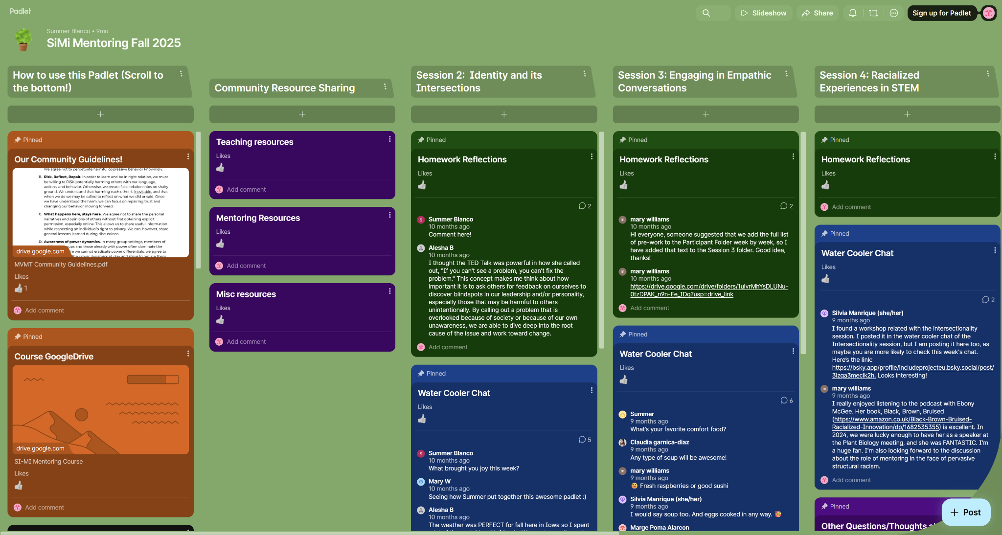
- Below is an example from the 2025 Padlet:

